**JDK** – It includes everything in the JRE, plus tools and utilities for Java development like javac compiler.

**JRE** – It provides an environment where u can run java programs

**JVM** – java program runs inside jvm

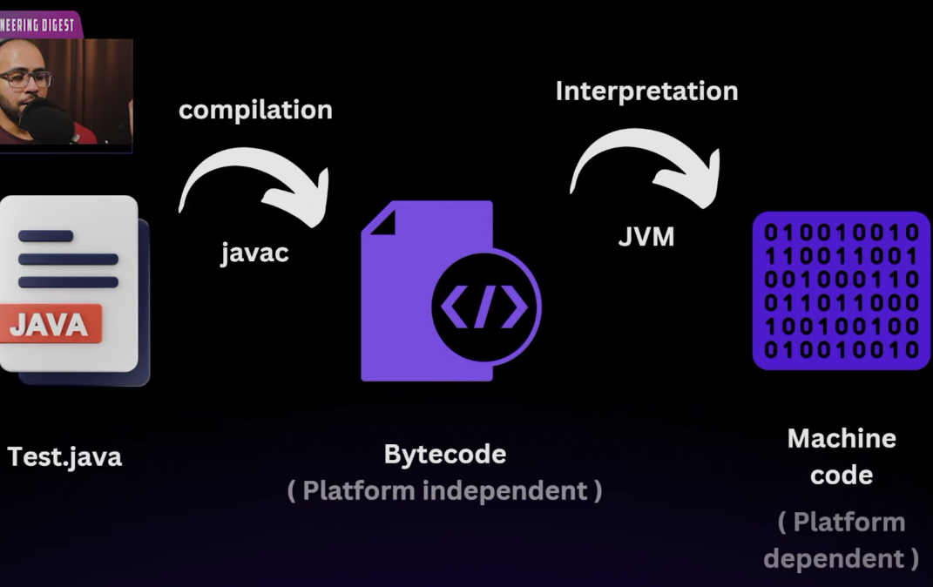

Javac test.java => produce bytecode in test.class file

Java test => jvm convert to machine code and run it.

JVM also uses JIT compiler to improve performance. Frequently executed code is **compiled to machine code by the JIT compiler** and cached, so subsequent executions are much faster.

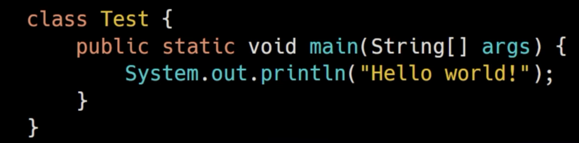

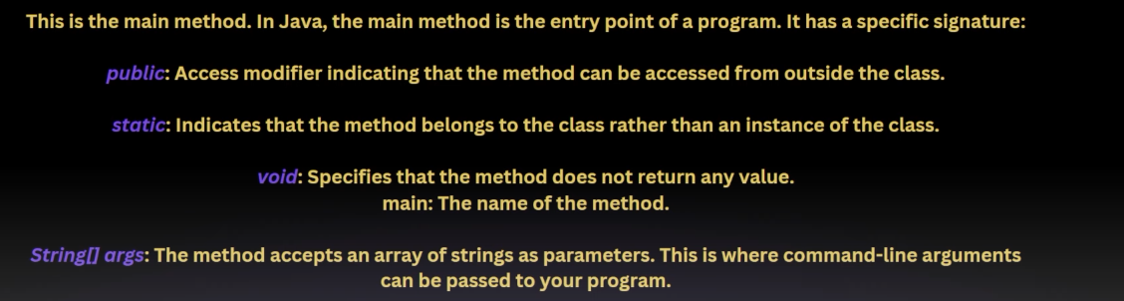

Main method is public so that JVM call access this method using ClassName.main() and start executing our program. JVM can call main method without creating object.

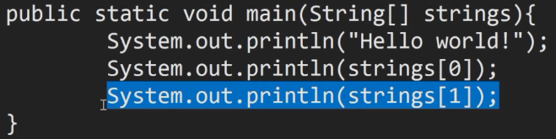

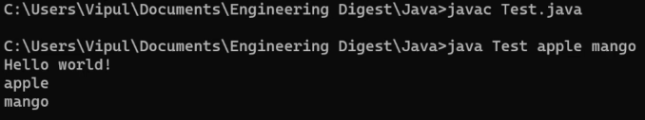

Access min and max values like this - 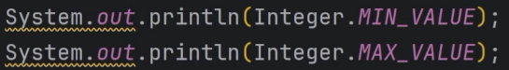

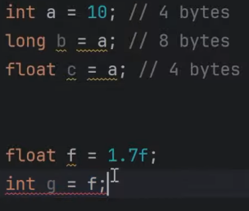 Java does not automatically convert because there is loss of decimal part, we need to do explicity type casting.

**Note :- unsigned right shift ( >>> ) it fills leftmost bits with 0s**

System.out.println(“Arjun”) 🡪 out is static member of System class

Println() 🡪 it appends new line after printing

Print() 🡪 print without appending new line

Printf() 🡪 System.out.printf("Name: %s, Age: %d", "Arjun", 25); // Output: Name: Arjun, Age: 25

**Strings**

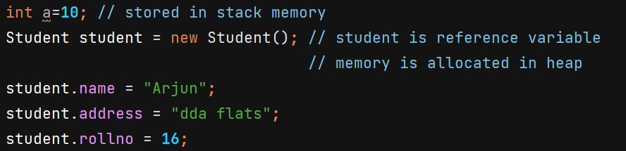

When we first time write any string literal, then JVM puts that in string pool which is portion in heap memory. And whenever we write that string again, it will point to the same memory location in string pool.

Reference variables are stored in stack memory which points to memory location in heap memory. If a reference variable is an instance variable (i.e., belongs to an object), it is stored in the **heap memory**, as part of the object.

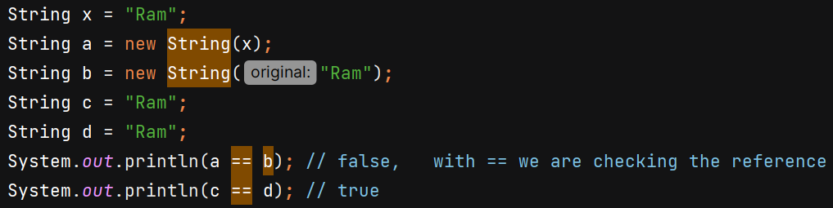

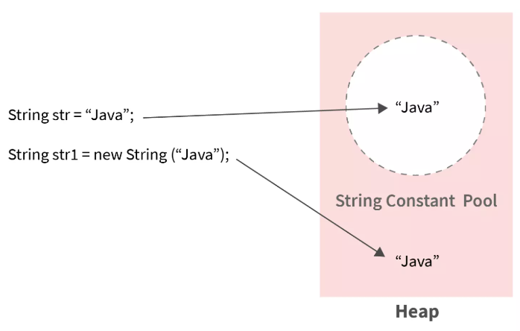 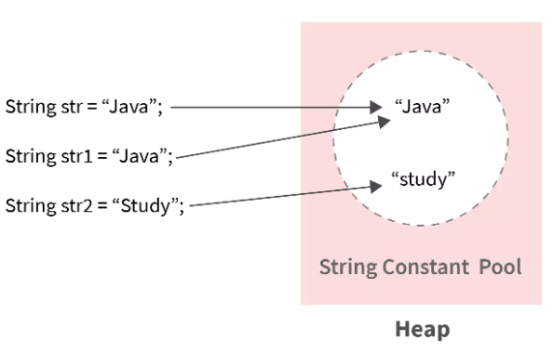

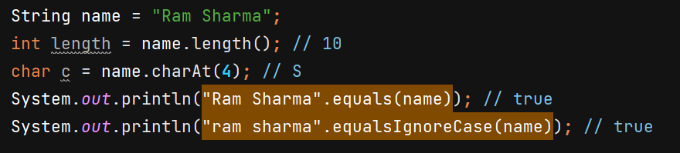

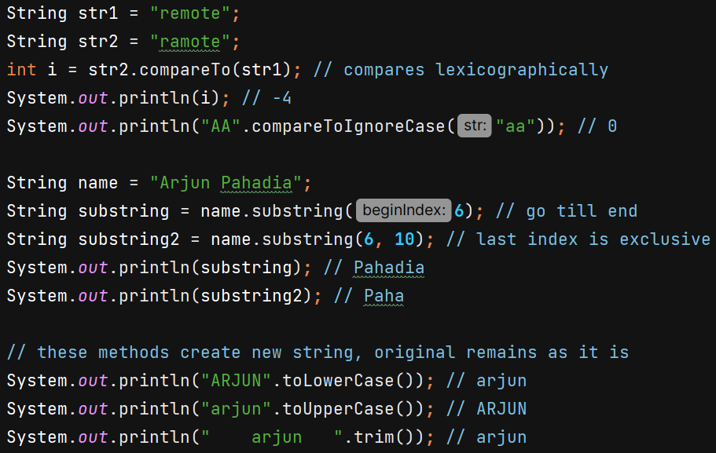

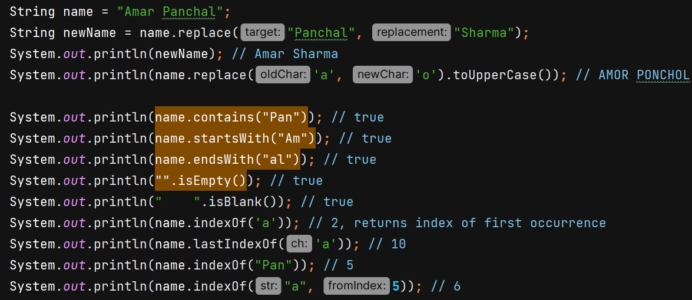

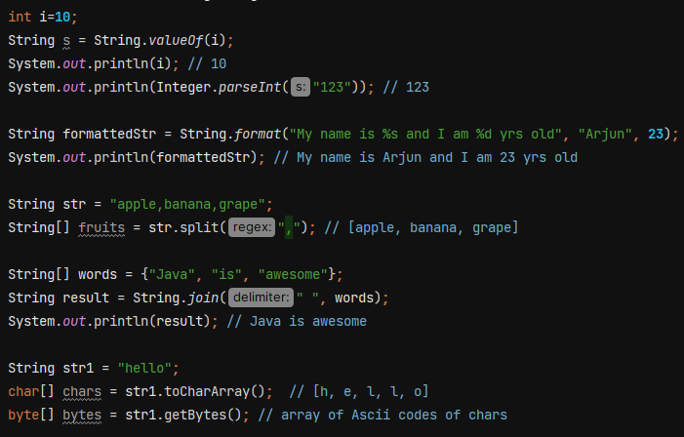

**Note :-**

* A String is immutable, meaning once created, its value cannot be changed. Any modification results in the creation of a new String object. It is thread-safe.
* A StringBuilder is mutable, meaning you can modify its content without creating a new object. It is not thread-safe.
* StringBuffer is mutable, allowing modifications without creating a new object.

It is thread-safe, meaning all methods are synchronized, making it slower but safe to use in multi-threaded environments.

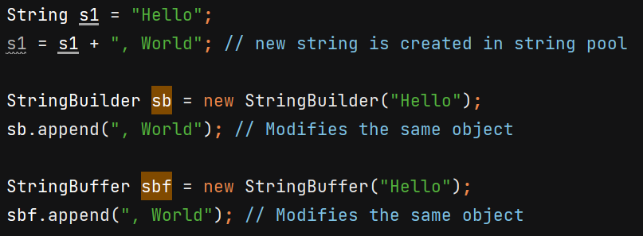

**Arrays**

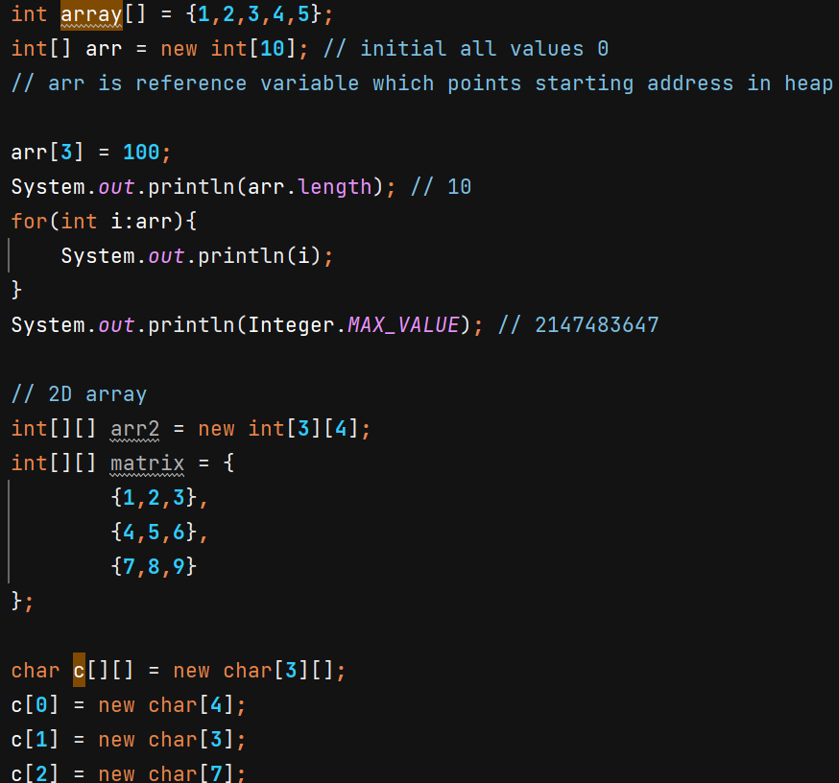

**OOPS**

It is programming paradigm in which we deals with classes and objects.

**Class** is a blueprint for objects. Ex – Car has properties like brand, model, color, max speed and has behaviours like accelerate, brake, etc. These properties and behaviours are defined in a blueprint.

We can create multiple objects of Car from Car class which gives blueprint for it.

**4 Pillars of OOPS**

* **Encapsulation** – Clubing of data and methods into a single unit called class. It focuses on restricting access to data and methods. We achieves it by:

1. Making fields (variables) private
2. Providing public getter and setter methods to access and modify the private fields.

* **Inheritance** – It allows child class to inherit some properties and behaviours from parent class. It helps in code reusability.

Ex - 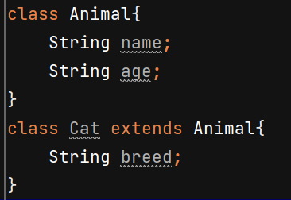

Types of inheritance :–

* 1. Single Inheritance - a **child class** inherits from only one **parent class**.
  2. Multilevel inheritance - a **class inherits from another class**, and then another class **inherits from it**, forming a chain.
  3. Hierarchical inheritance - **multiple child classes inherit from a single parent class**.
  4. Multiple Inheritance – Java does not support it to avoid diamond problem. However, Java supports multiple inheritance through interfaces.

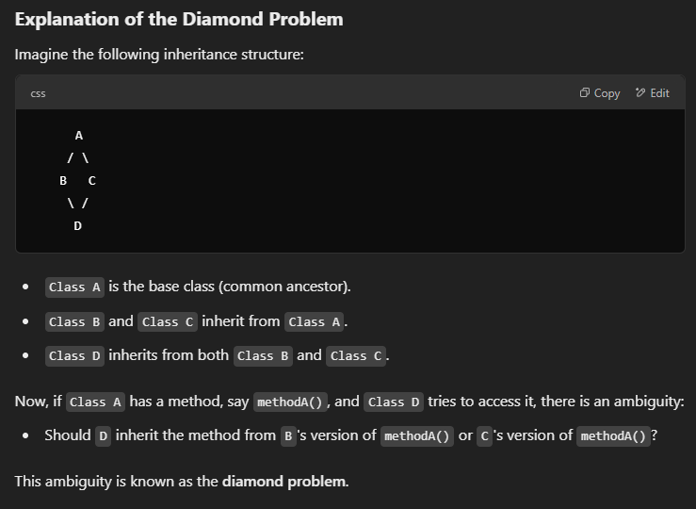

Order of constructor called –

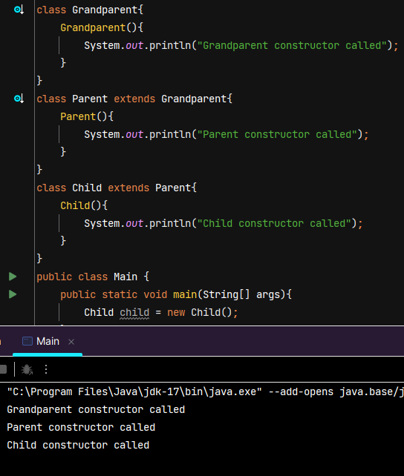

**Note :- this keyword refers the current instance of object**

**Super keyword refers the immediate parent of child class**

When a child class constructor is invoked, the compiler **automatically inserts a call to the parent class's no-argument constructor (super())** at the very beginning of the child constructor. We can also do this explicity but it should be done at beginning.

If the parent class does **not** have a no-argument constructor and instead has a parameterized constructor, the compiler **cannot insert super() automatically**. In such cases, you **must explicitly call the appropriate parent class constructor** using super(arguments) and pass the required arguments.

The parent class must initialize its part of the object before the child class can initialize its own fields.

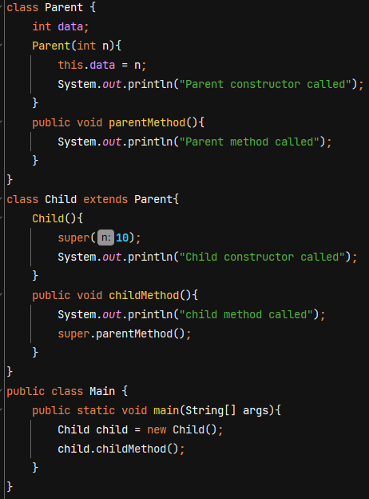 ‘this’ in Parent constructor refers to the child class object as the control flow reached there after we created child class object. No object of parent was created.

O/P 🡪 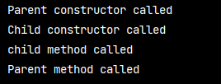

* **Polymorphism** – literally means "many forms”. In programming, it means the ability of code to behave differently in different context.

**Types –**

1. **Compile time –** for a set of code we’ll decide at compile time what operation to perform and its behaviour. It can be achieved by method overloading (decide at compile time which function to call based on the parameter)

Method overloading – same name but different parameter list

Ex- 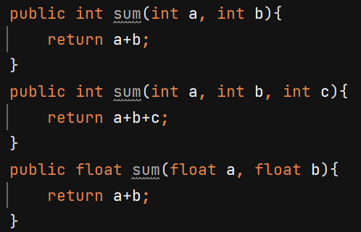

Note :- we differentiate methods based on signature (name + parameter list) not return type.

Error - 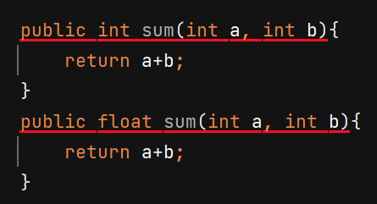

1. **Runtime –** we decide at runtime what operation to perform and the beaviour of code. It can be achieved by method overriding.

Ex – Dog & Cat class overrides the makeSound() method of parent class Animal.

Reference variable of parent class can hold the memory address of child class object.

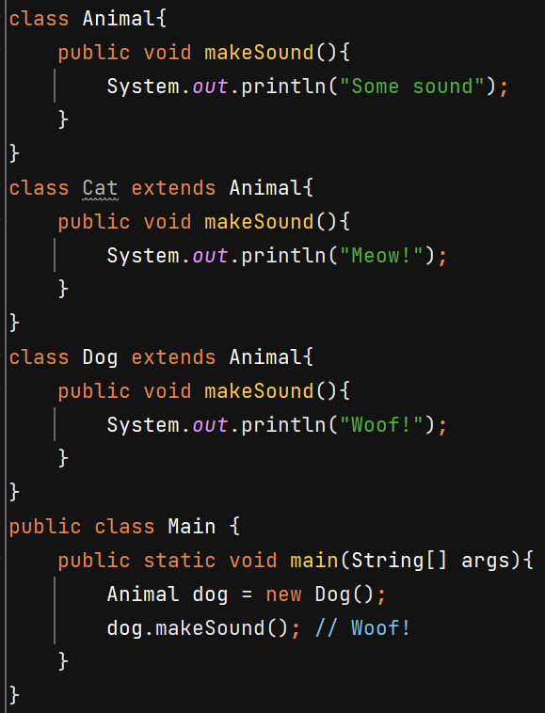JVM will decide on runtime whose makeSound() method to call.

It is also called dynamic method dispatch or Upcasting.

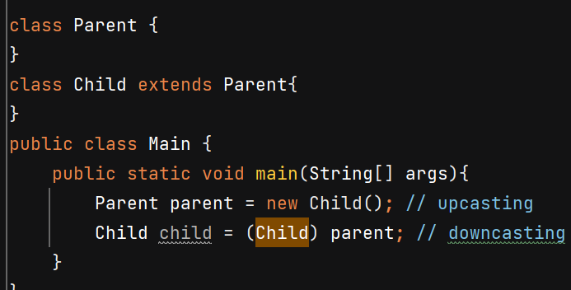

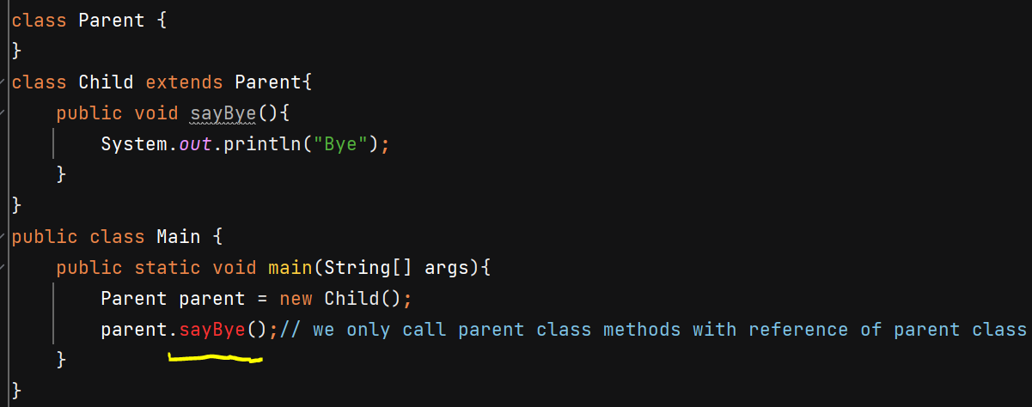

* **Abstraction** – hiding implementation details from end user. Ex- we press the TV remove button to increase/decrease volume but we don’t care how remote works internally. We just care about the fact that on pressing the volume should increase/decrease.

It can be achieved using abstract class. Abstract class can have 0 or more abstract / concrete methods. We cannot make object of abstract class. But we can write constructors for abstract class as it will be used for doing initial setup when instantiating child class objects.

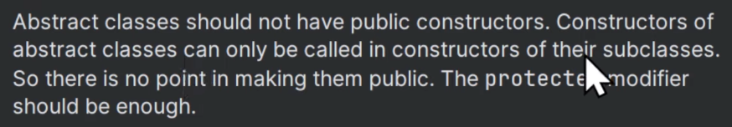

A class which extends an abstract class should either override the abstract methods of parent class or make the child class also abstract.

Abstract methods of an abstract class should not be private as they wont be accessible outside class. We’ll get ERROR

If u don’t mention access modifier (package private) then its child classes in other packages cannot override it as that won’t be accessible there. So making it protected can help. (it will be accessible within same package and inside child classes). Now child classes can override it and write its own implementation.

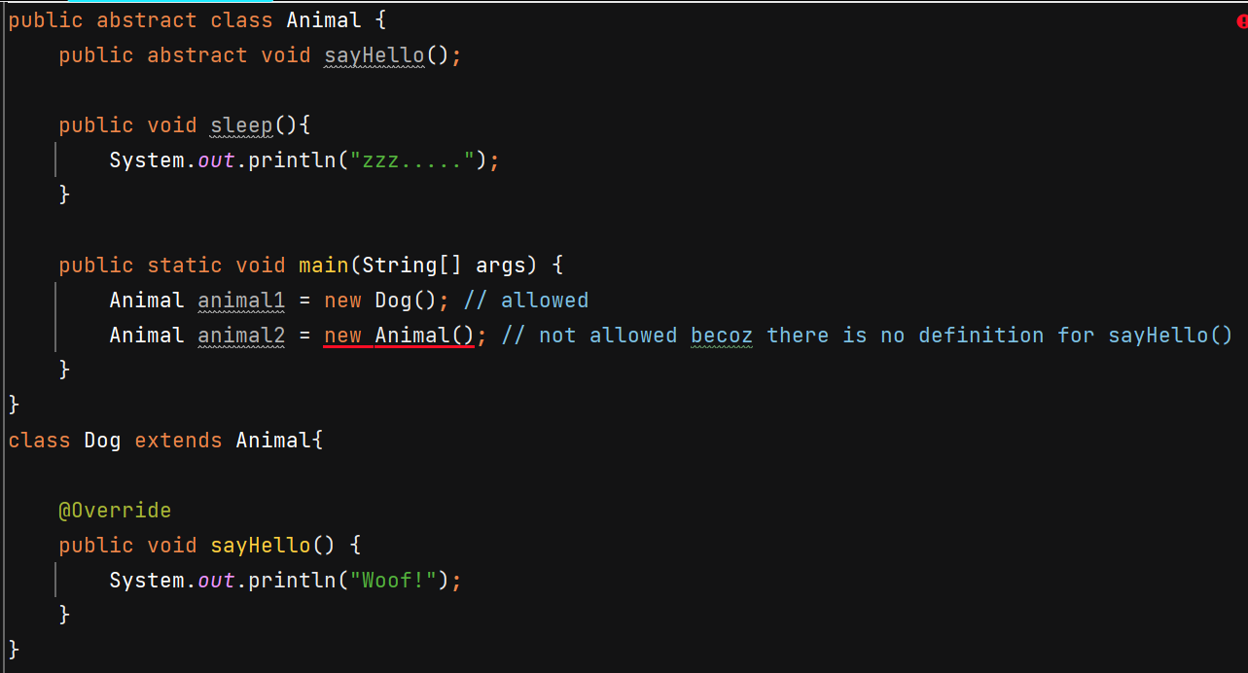

**Access Modifier** – keywords which describe the visibility of class, method and instance variables.

Private constructor – useful when u create a Utils class having all static methods and singleton class.

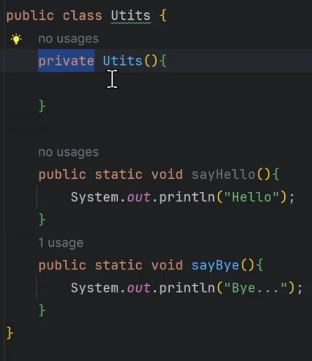 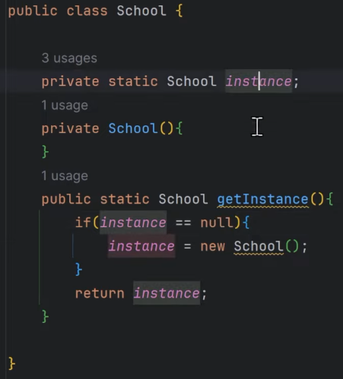

On class we can only have public or default access modifier.

**Protected**: The access level is within the package and outside the package through child class. If you do not make the child class, it cannot be accessed from outside the package.

**Default**: The access level of a default modifier is only within the package. It cannot be accessed from outside the package. If you do not specify any access level, it will be the default.

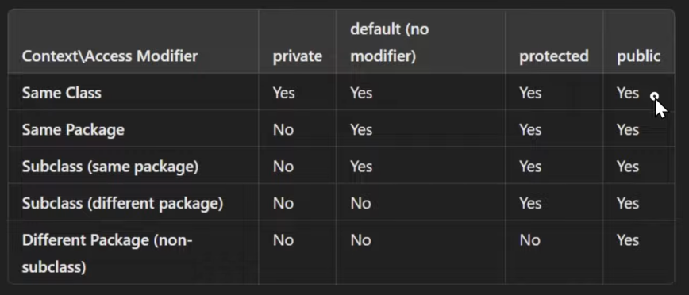

**Static Keyword**







Ex –

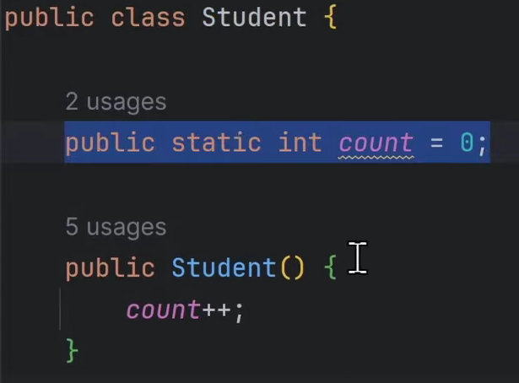 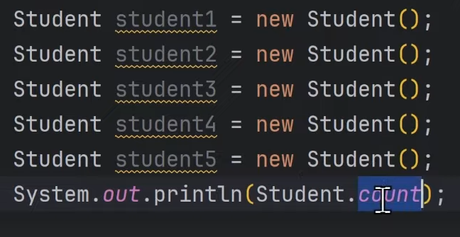

O/P 🡪 5

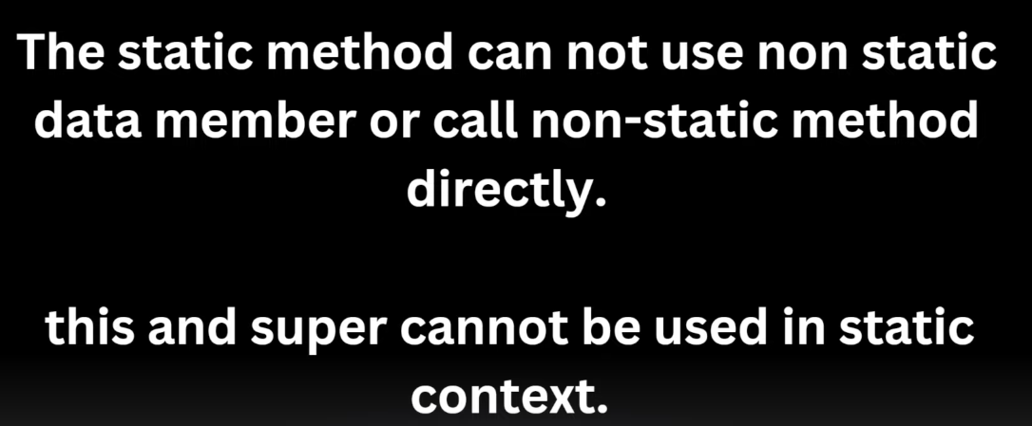

Note :- before any object is created or not, static variables are instantiated first.

Static block is used for performing static initialization, for 1 time setup task.

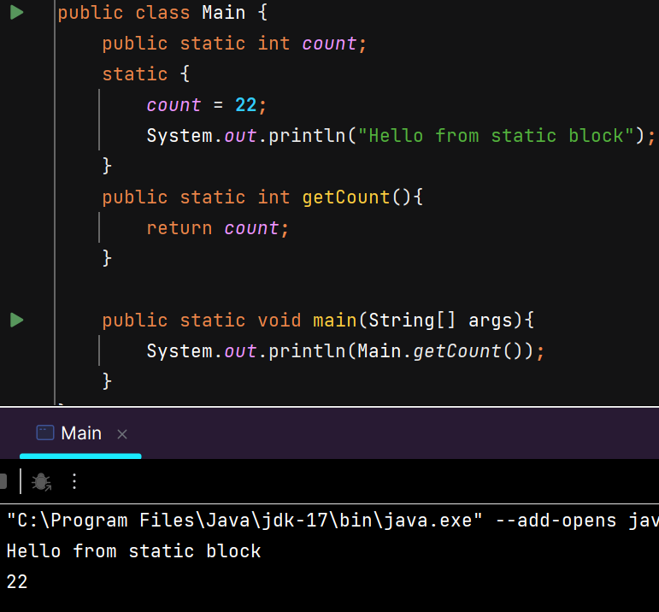

**Final Keyword**

Used with class fields to make them constants.

U can only assign value to a final variable at the time of declaration or in static block or insidde constructor if field is not static.

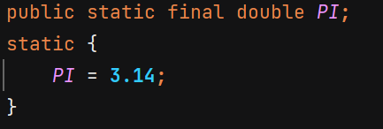 or 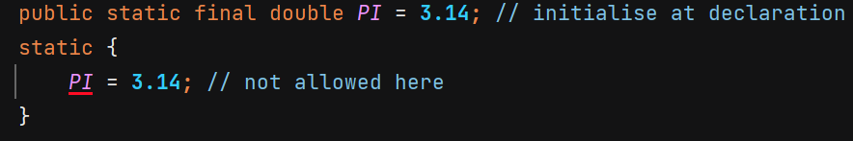 or 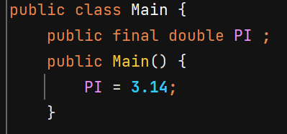

Final keyword can be used with methods if we want that no child class should be alllowed to override the method –

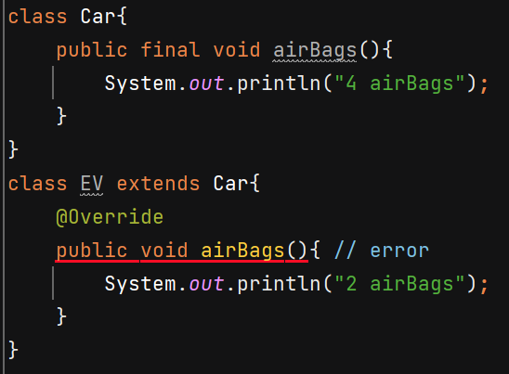

We can also make a class final if we don’t want any other class to extend our class –

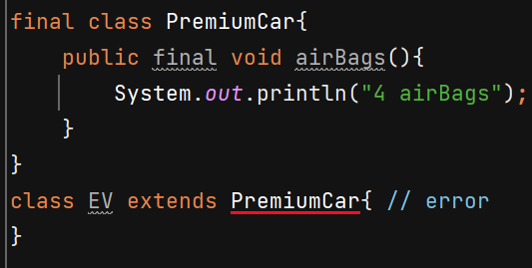

Using final on constructor makes no sense because we use final to prevent overrriding and constructor is already not inherited. There is not concept of overriding constructors.

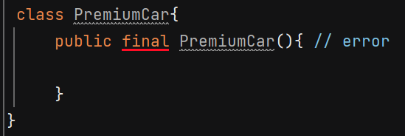

**Inheritance**

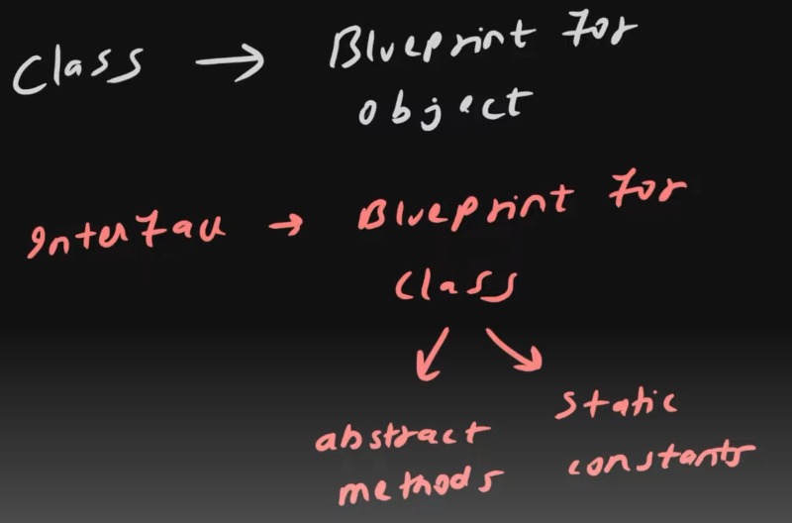 

Interfaces does not have concrete methods. Classes that implement the interface must provide the implementation for all its abstract methods, ensuring full abstraction.

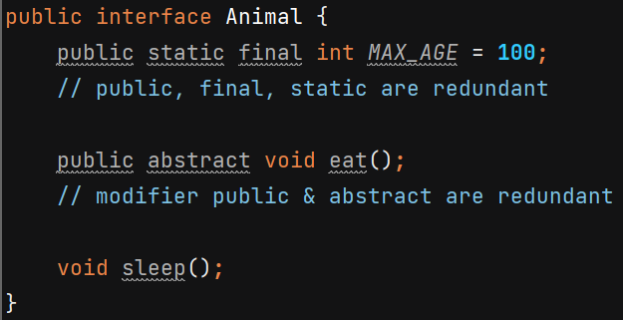

Class implementing Animal should either provide implemenation of eat() and sleep() or that class should be declared abstract –

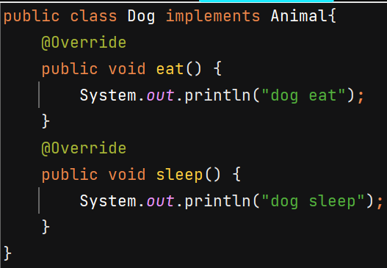 Or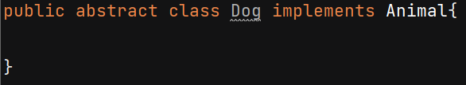

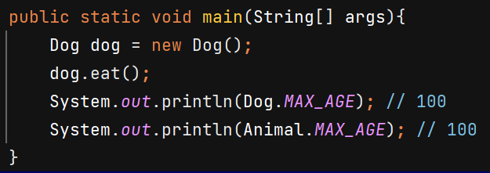

After Java 8, interfaces can have static and default methods –

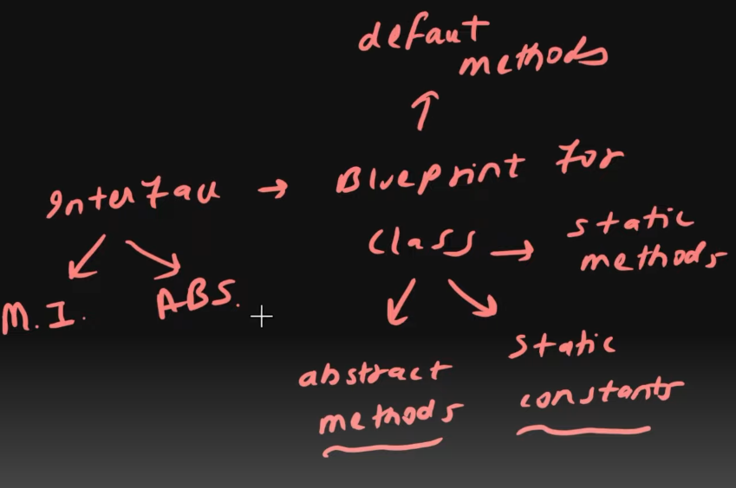

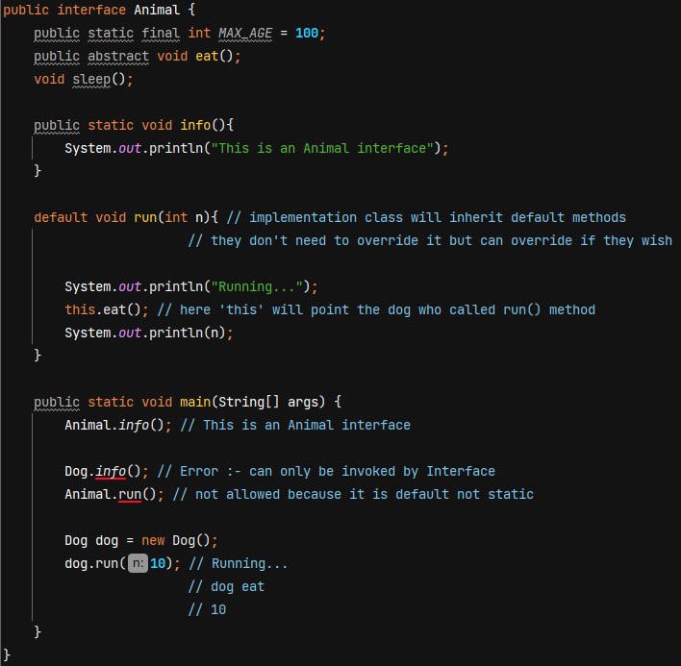

Multiple Inheritance in interfaces –

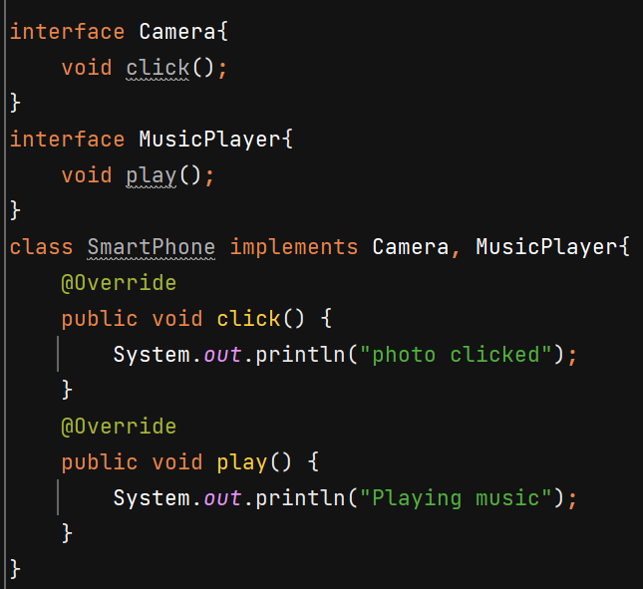

Difference between abstract class & Interfaces –

* Abstract class has instance variables and to initialize them it has constructor. But we don’t have these in interface
* 1 class only extend only 1 abstract class whereas 1 class and implement multiple interfaces.

**Inner Classes**

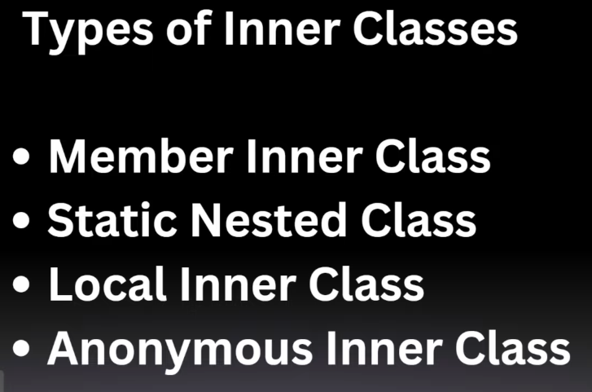

**Member Inner Class** – Inner will behave as member of outer class. It is associated with instance of outer class. Inside inner class methods we can access fields of outer class.

Engine is acting as a property for Car –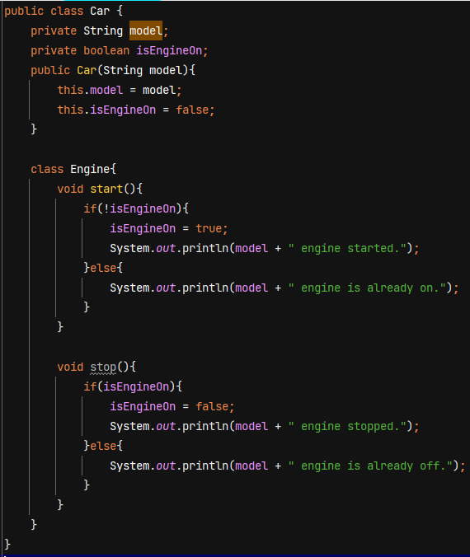

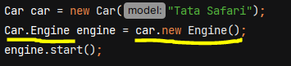

Without using it, our code increases as we need to create separate Engine class having Car as its instance variable –

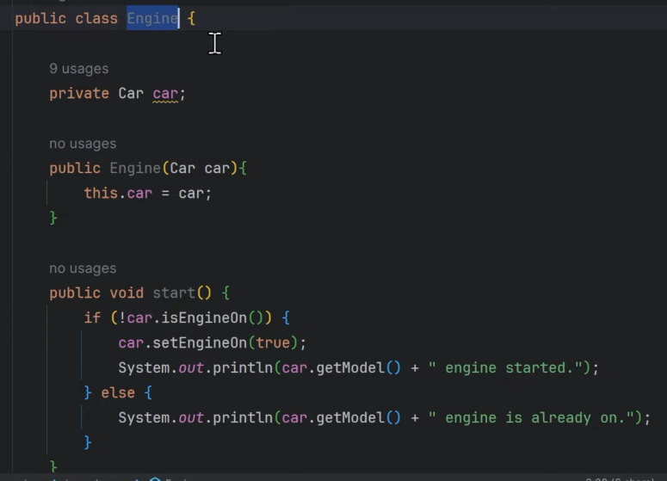

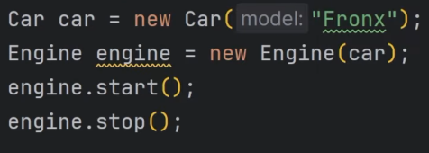

**Static Nested class** - It belongs to the outer classs rather than its instance.

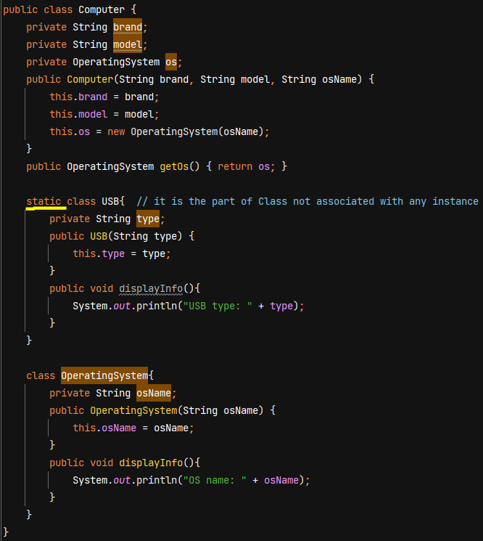

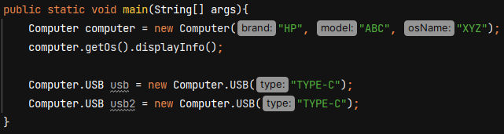

**Anonymous Inner class** – useful when we have to implement an interface without creating its separate implementation class or we have to extend a class without creating its separate child class.

Anonymous because it does not have any name.

Used for creating an object for 1 time use.

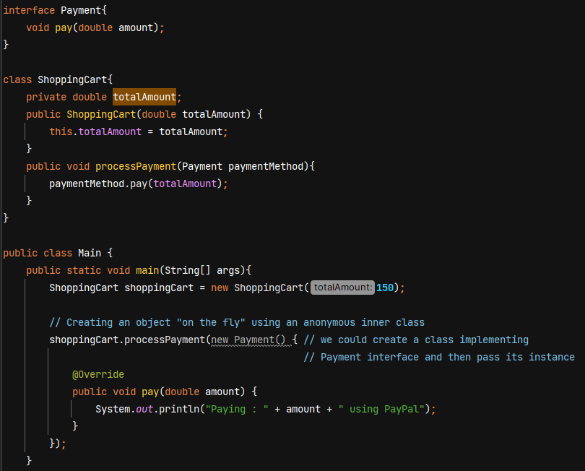

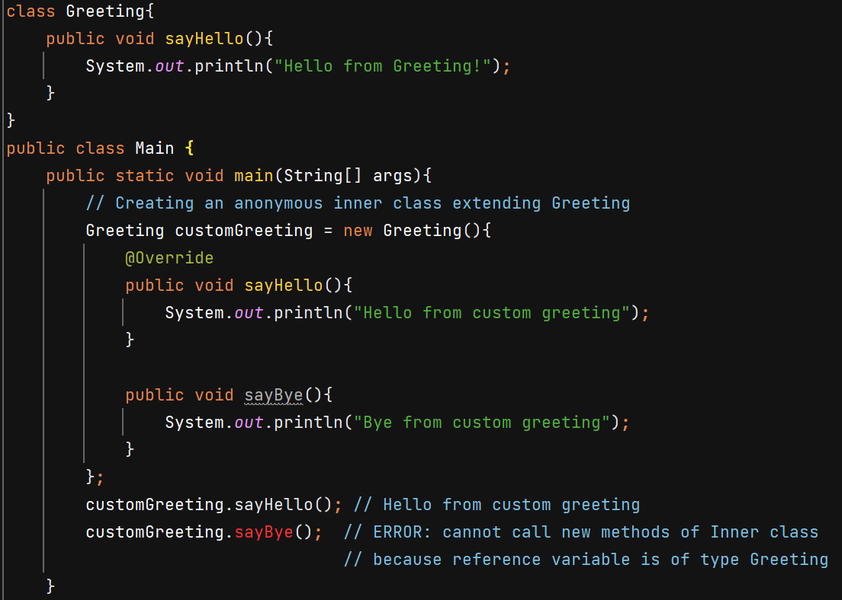

**Local Inner Class**

Used to encapsulate the logic. Ex - validation logic is tightly coupled with reservation process, so by placing the validation logic inside reserveRoom() we are setting the context that validate() function will only be used inside reserveRoom() method. So place it here only why to keep it outside.

Local Inner class can access all the instance variables of object.

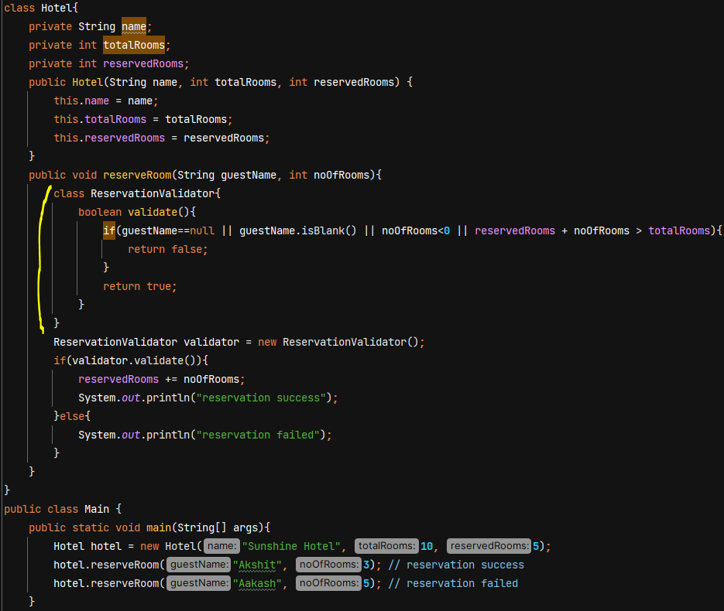

Note :- Java is not a pure object oriented language because it still has primitive data types like int, float, double, etc. In Collection we cannot use primitve data types.

**Wrapper Classes** – used to wrap primitive data types into an object so that we can use methods on it.

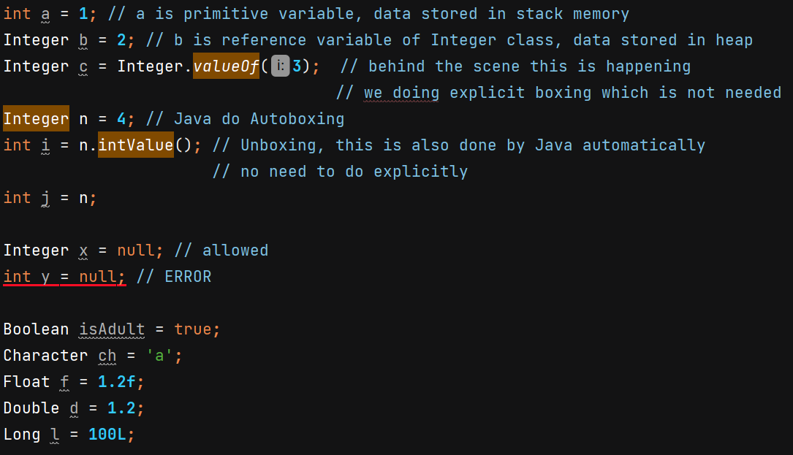

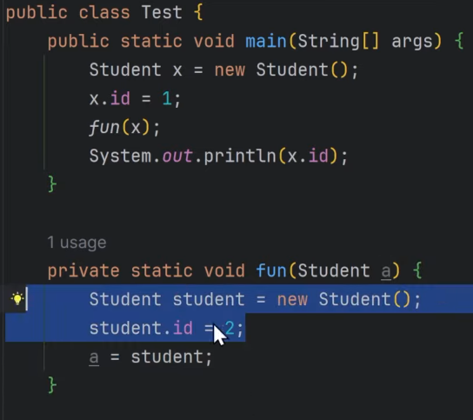 O/P 🡪 1

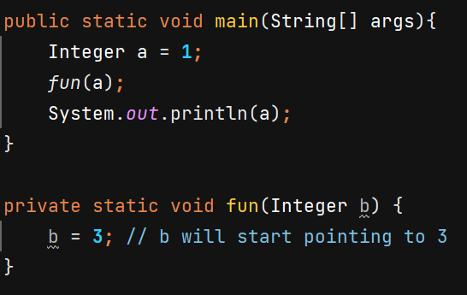 O/P 🡪 1

In Java, the Integer class is immutable, meaning its values cannot be changed once they are set. However, when you perform operations on an Integer, a new instance is created to hold the result.

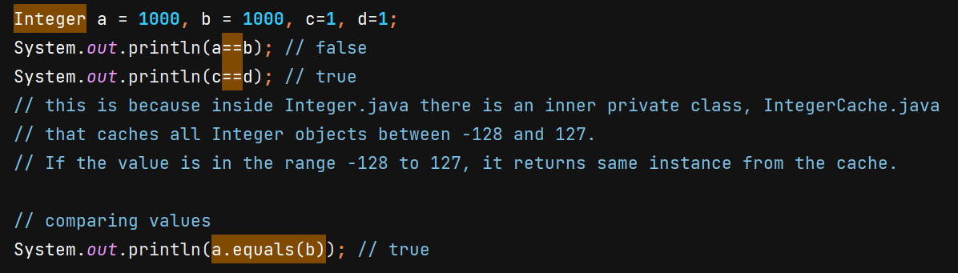

**Enums** – used for storing fixed set of constants

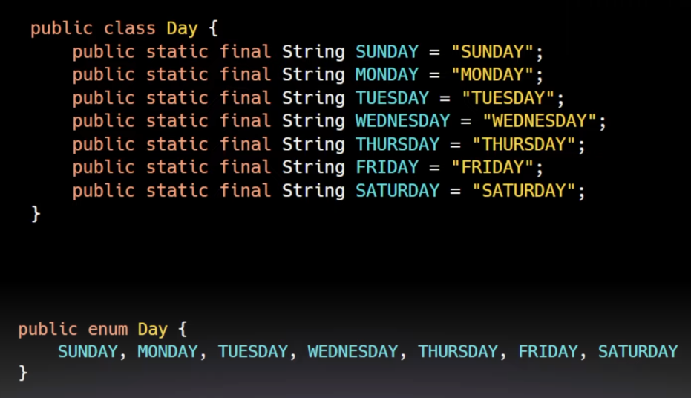

SUNDAY is a Day, MONDAY is a Day, …. They are final instances of Day class

On compile time, Day enum becomes a final class which extends Enum<Day> class –

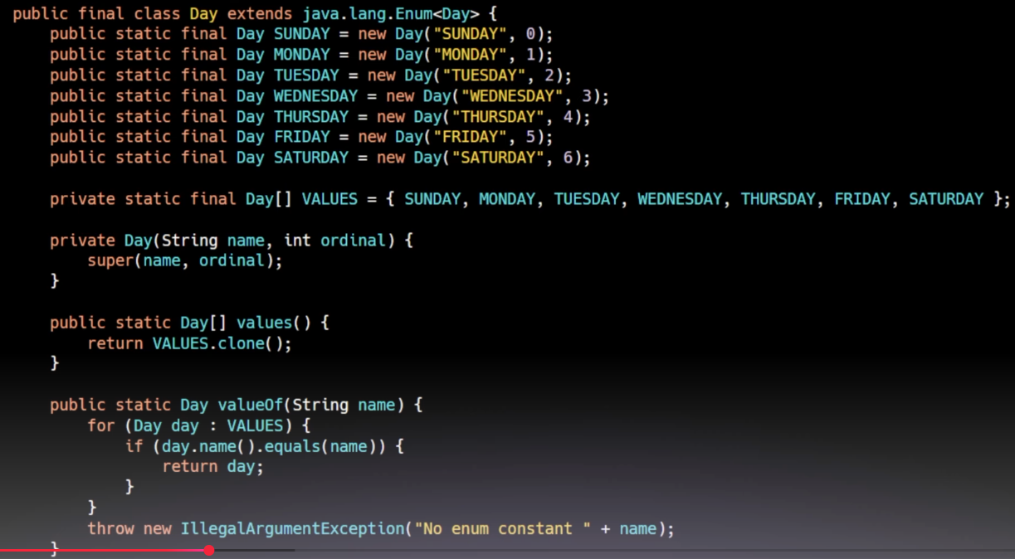

Note :- In enum, the first thing you write should be enum constants. After that we can add fields and methods.

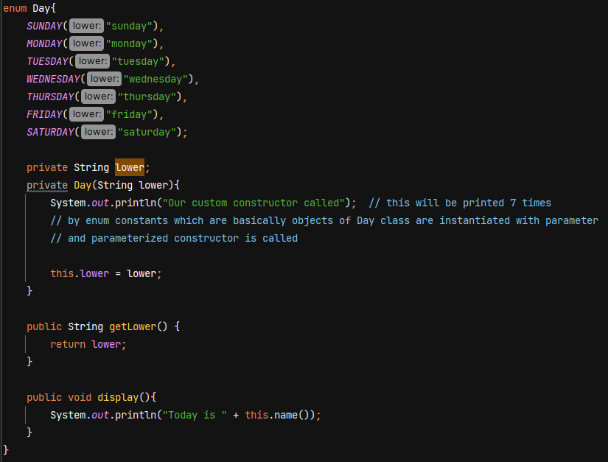

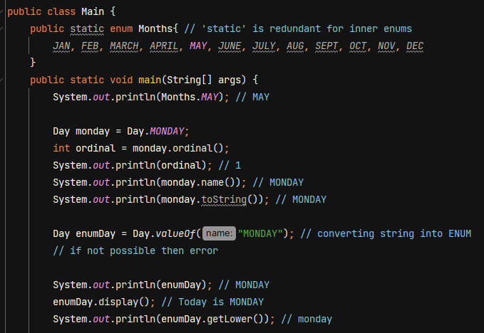

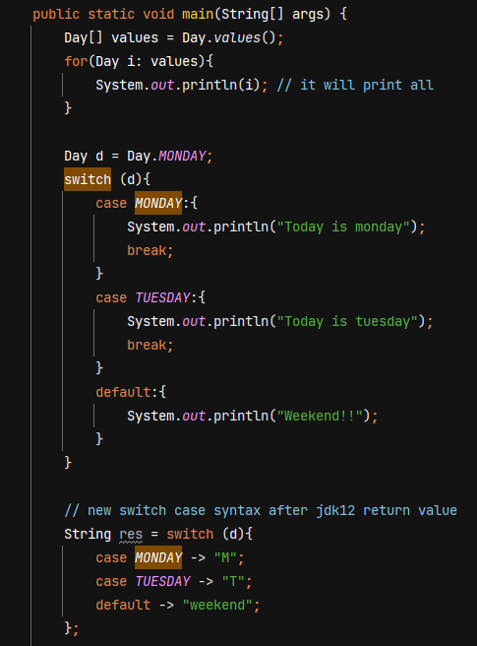

**Exception Handling**

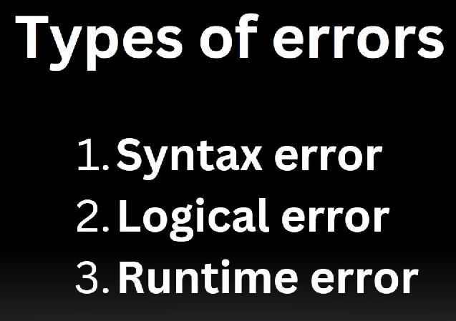

Program will crash during run time errors.





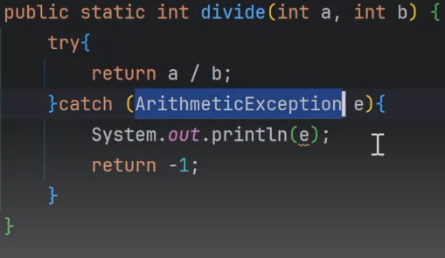 sout() uses toString() method to print object,

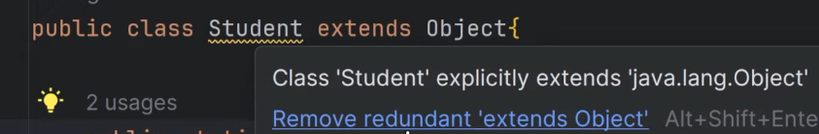 Every class extends Object class.

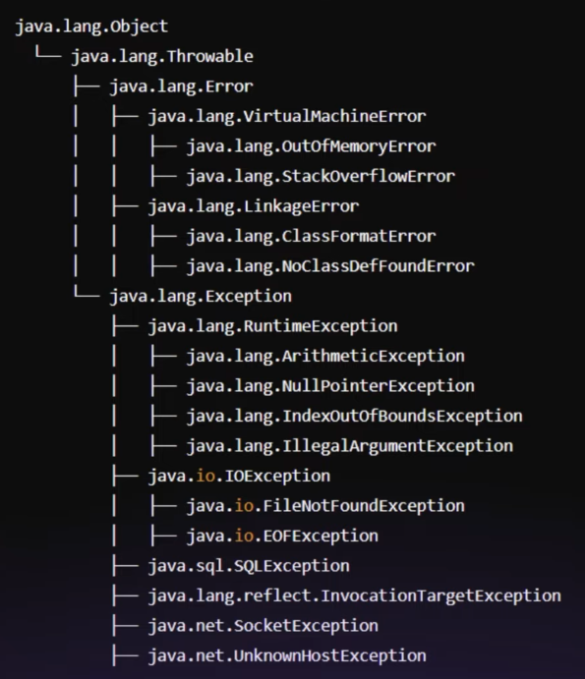

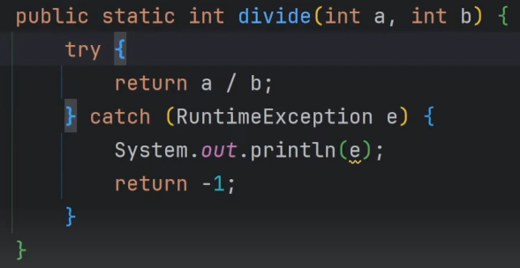 Reference variable of type RuntimeException can point to the object of ArithmeticException.

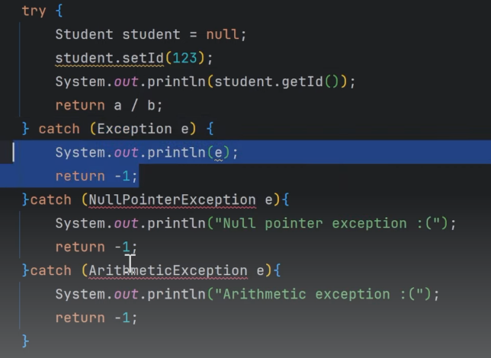 Error :- exception has already been caught

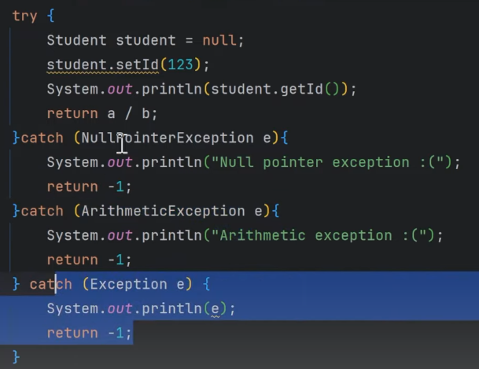 Correct way of catching exception

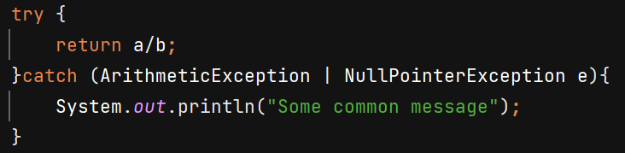 Catch multiple exceptions like this.

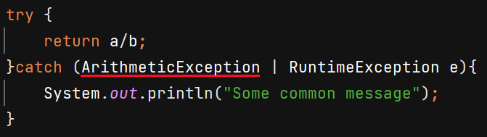 Error :- Types in multi-catch must be disjoint: 'java.lang.ArithmeticException' is a subclass of 'java.lang.RuntimeException'

**Unchecked Exceptions** – These exceptions are not being checked at compile time. Ex- ArrayIndexOutOfBound, NullPointerException, etc.

**Checked Exceptions** – which are checked at compile time. 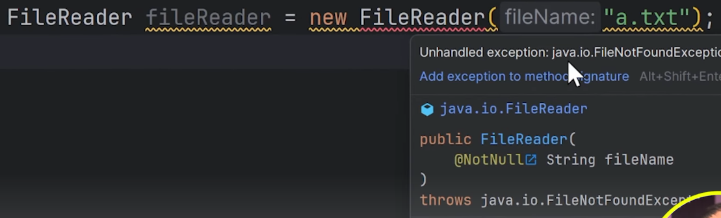

It will say to handle the exception.

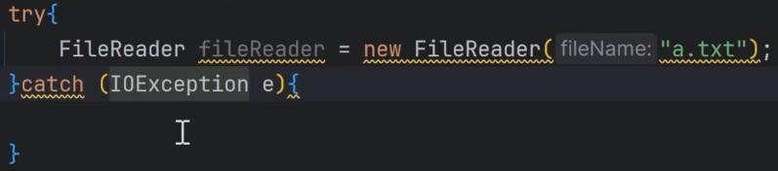

**Throws** – using it we put the responsibility on caller of method to take care of exception. Caller should either use try-catch or throw the exception or else JVM will handle it by terminating the program.

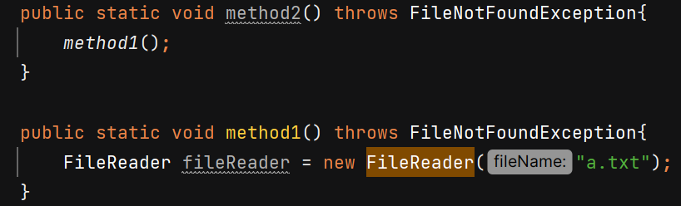

**Throw** – used to forcefully throw exception

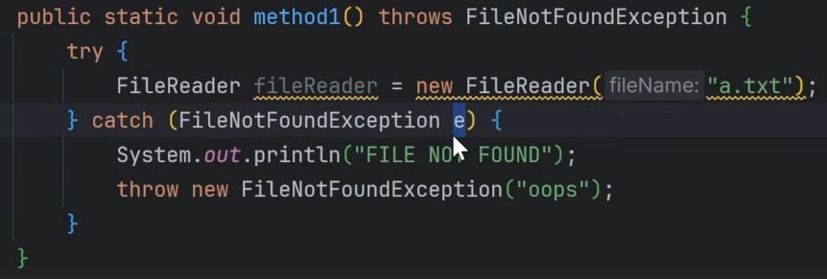

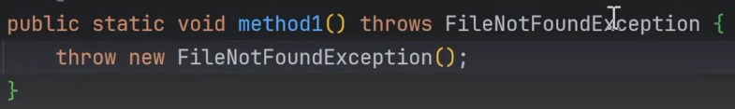 Here we have to use **throws** keyword also because FileNotFoundException is checked exception so we need to make the caller aware about it so that caller will handle it.

But if we **throw** unchecked exception then using **throws** is not necessary – 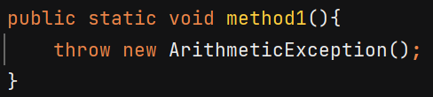

When throwing **Exception** we need to use throws because its parent class for checked exceptions - 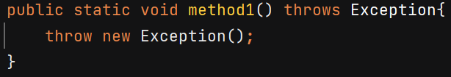

**Finally** –

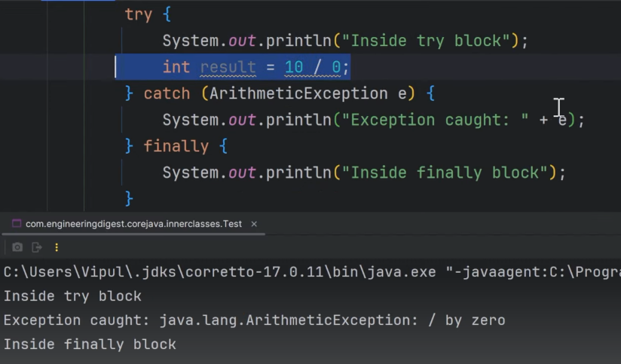

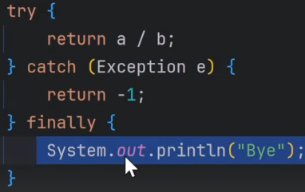

Object of BufferedReader must be closed, we can do it in finally block – 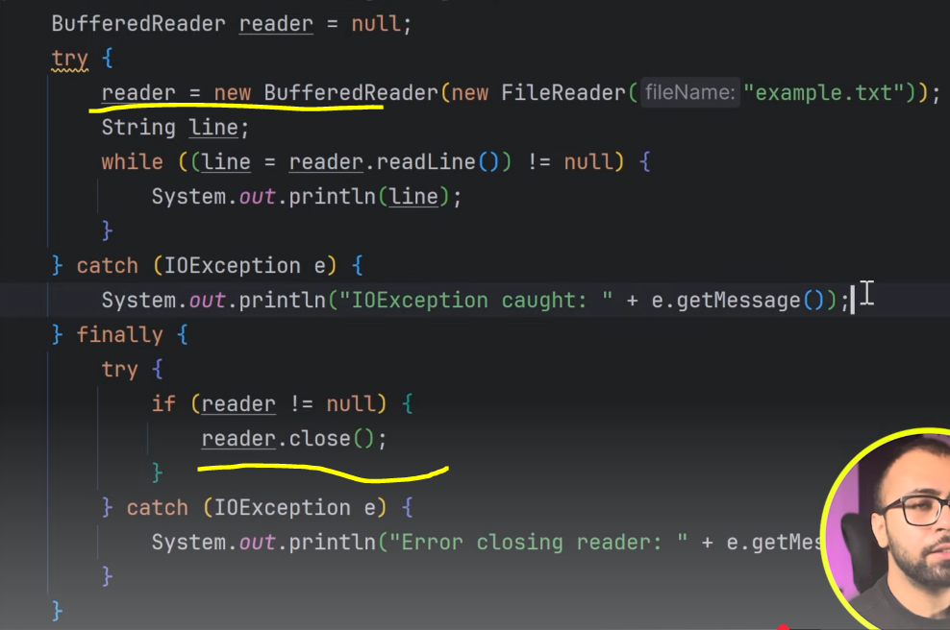

**Try-with-resource**  - no need of writing finally for closing resources

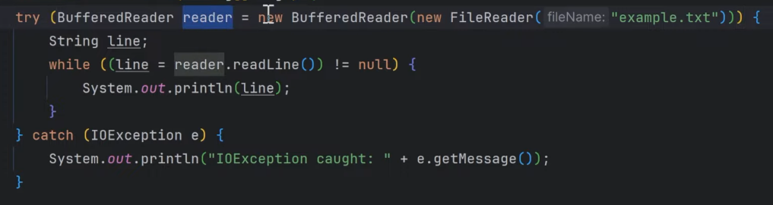

Object created within () will be closed automatically if that object class implements AutoCloseable interface.

**Custom Exception Class**  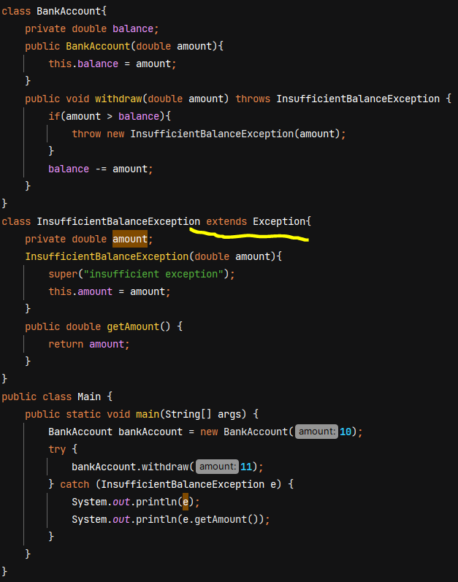

**Generics**

Ex- ArrayList stores array of Object class instances -

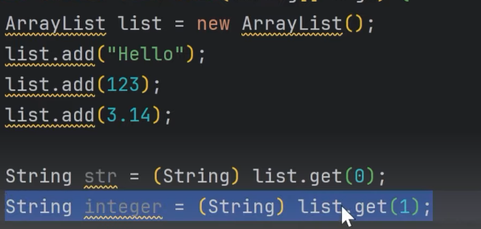 ClassCastException at runtime

Issues without generics - 

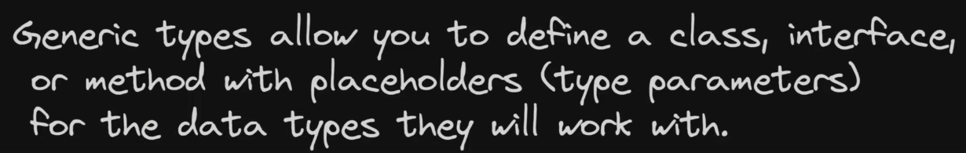

It helps avoid duplication of code and giving compile time error making it type safe.

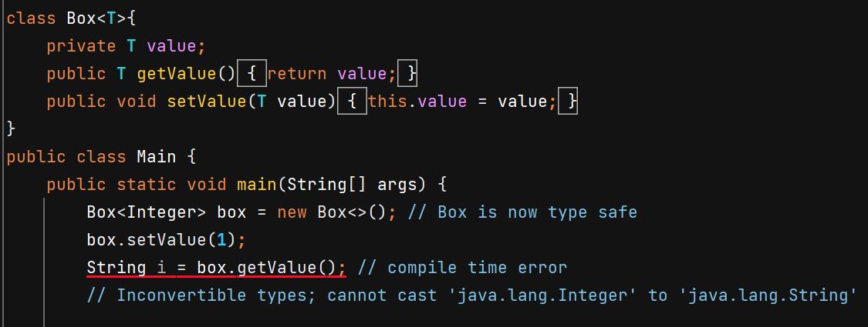

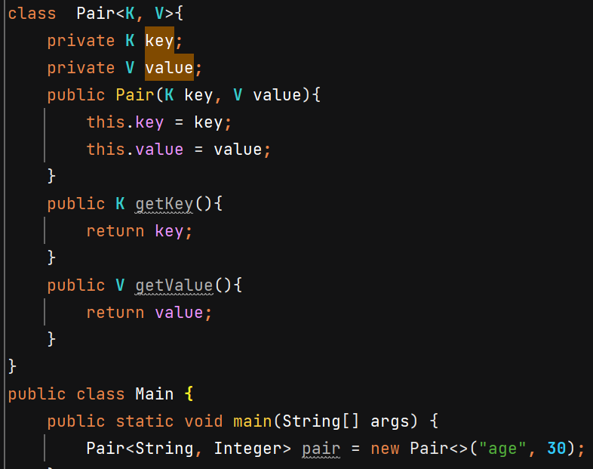

Generic Interface –

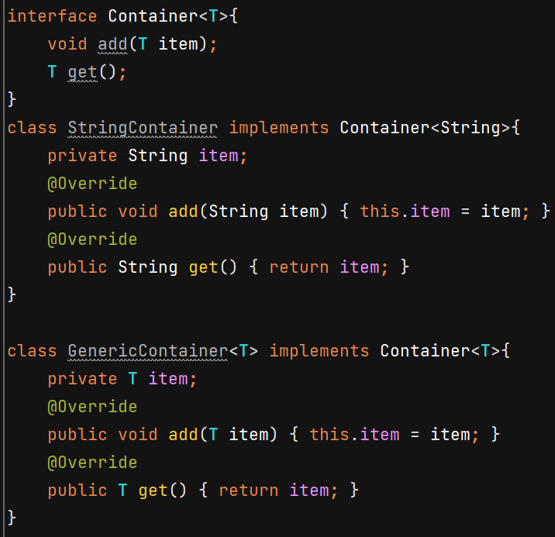

Bounded type parameters –

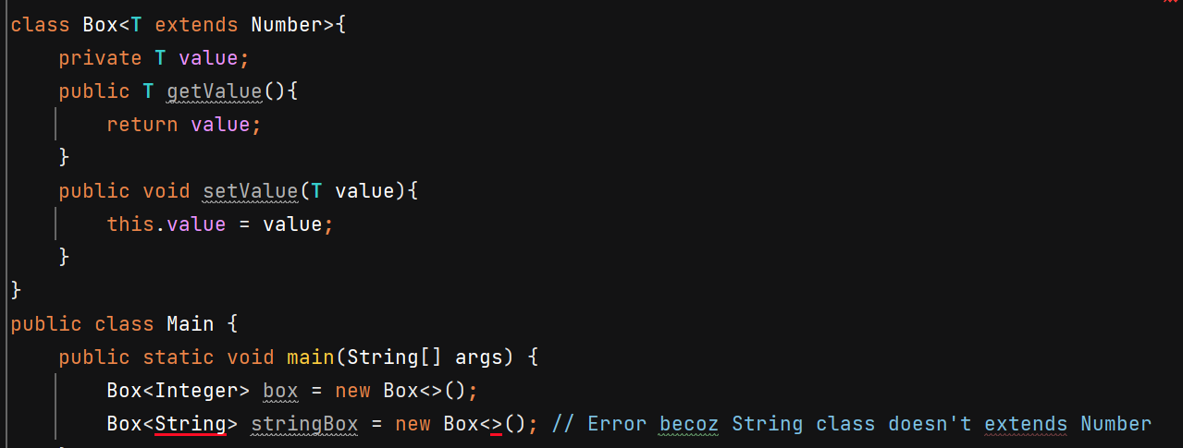

Multiple bounds –

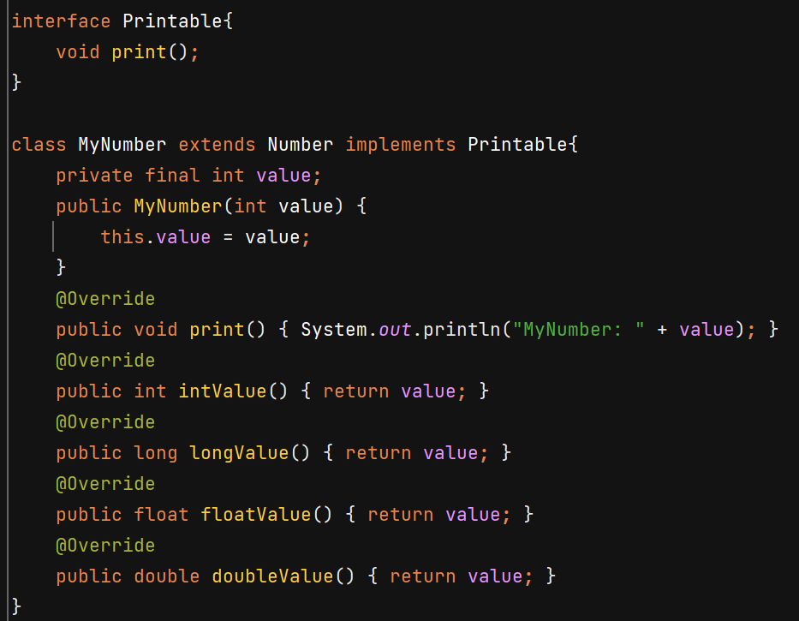

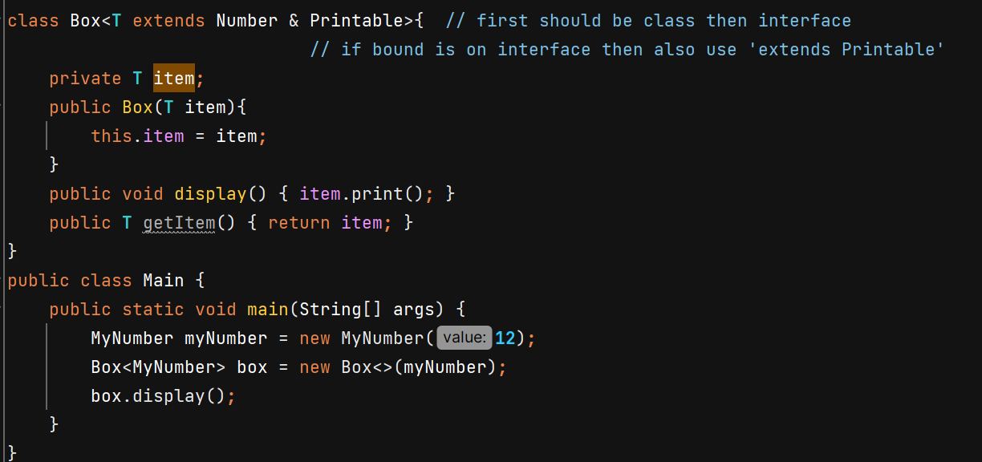

Generics in Enum 🡪 enums are already type safe

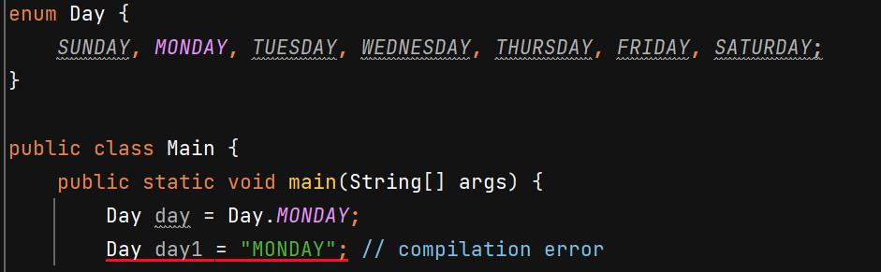

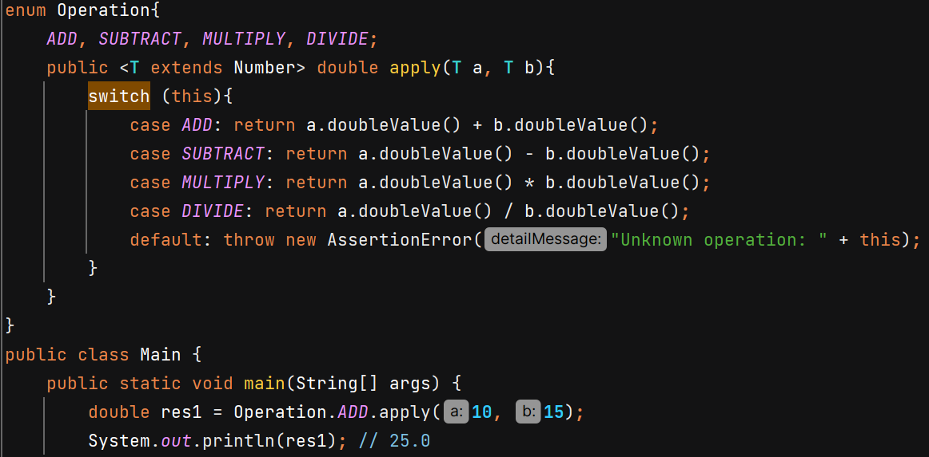

Generics Constructors – a non generic class can have generic constructor

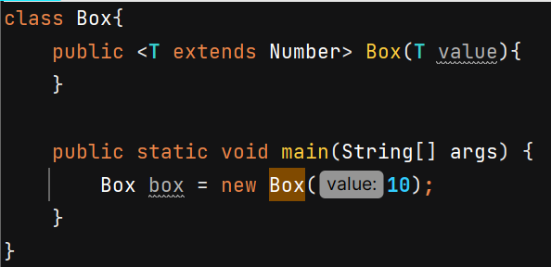

**Generic Methods** –

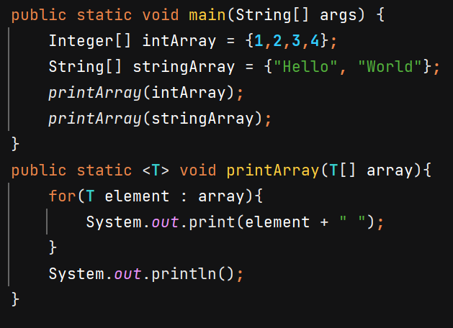

Method overloading –

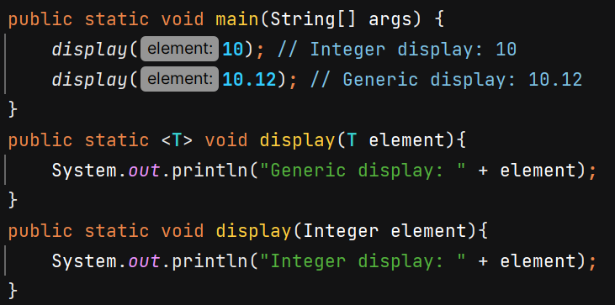

**Wildcard –**

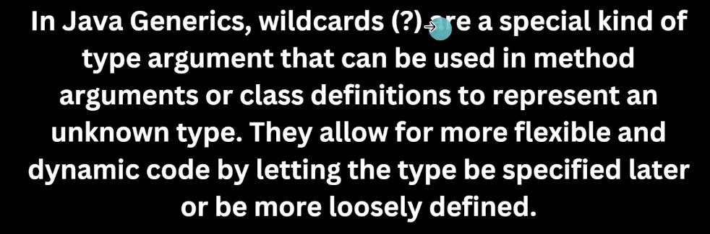

If the method is read only and does not return a value or perform any write operation, then mentioning T is not necessary and we can use ? wildcard just for simplicity.

When we return something we’ll use T to maintain type safety.

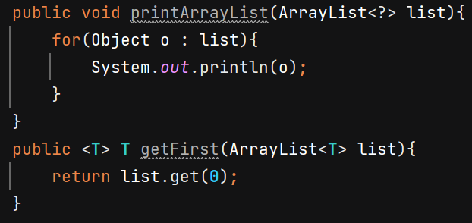

We’ll get error if doing write operation with wildcard –

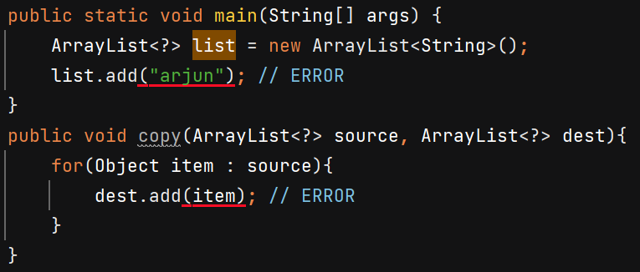

Boundation with wildcard –

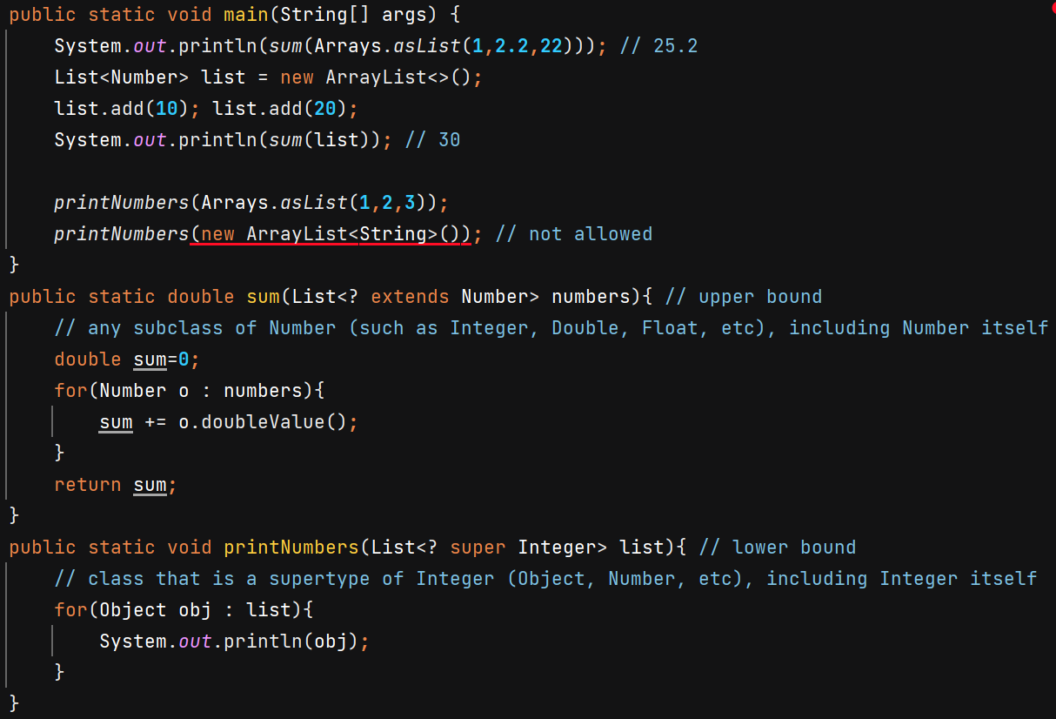

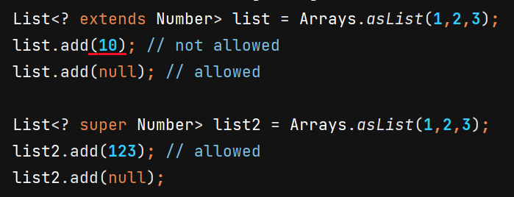

In super it will get added as Object, but in extends we don’t know what exactly is the type that’s why it doesn’t allow to add.

**Type Erasure –**

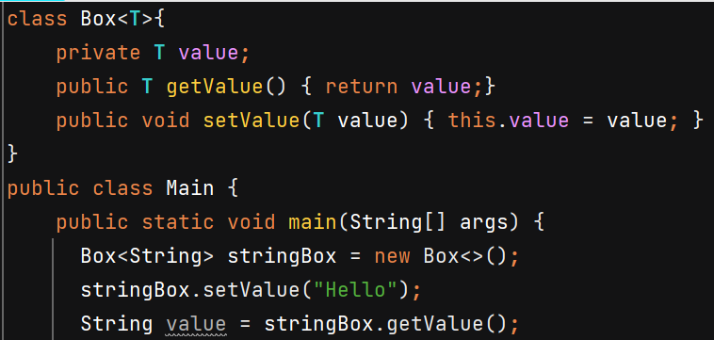

When u add value compiler will check whether u r adding String or not. But in bytecode, there are no Generics. Box<String>, the String gets erased. So after doing type checking compiler will erase information of generics.

Internally after compilation, it will look like – 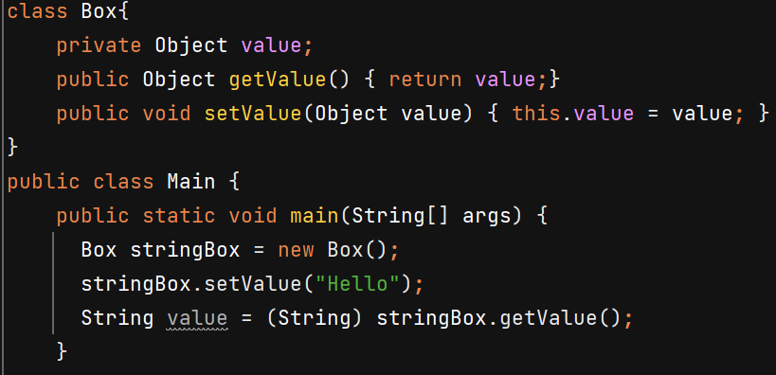

Ex2 – 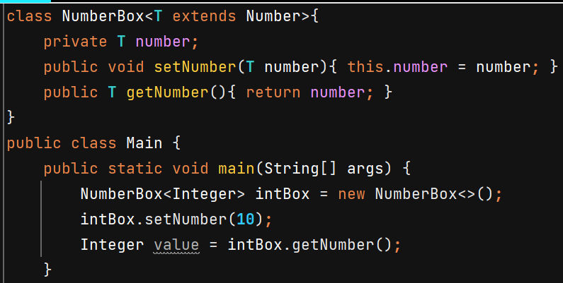

After compilation - 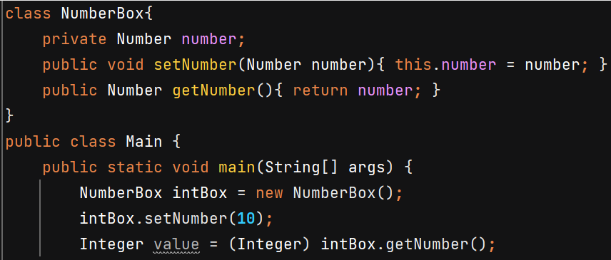

**Generics Exception -**

It becomes little bit complicated because Exceptions are thrown at runtime and on runtine there is no generic information due to type erasure but JVM needs exact type to create exception object.

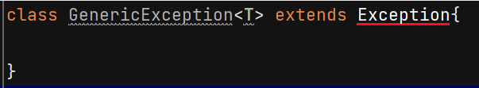 Compilation Error

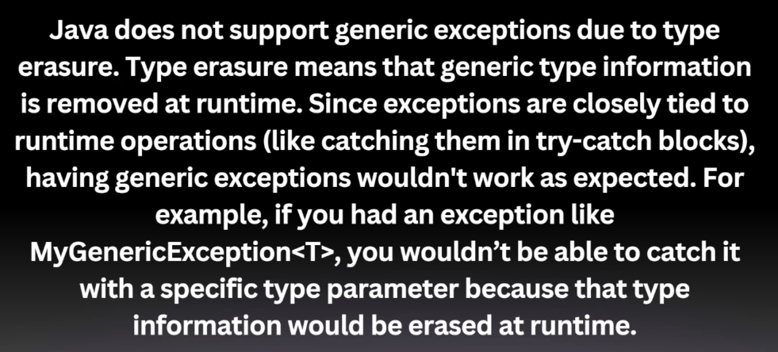

Workaround – 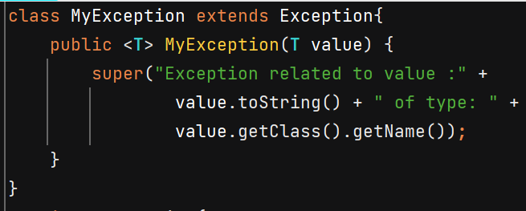

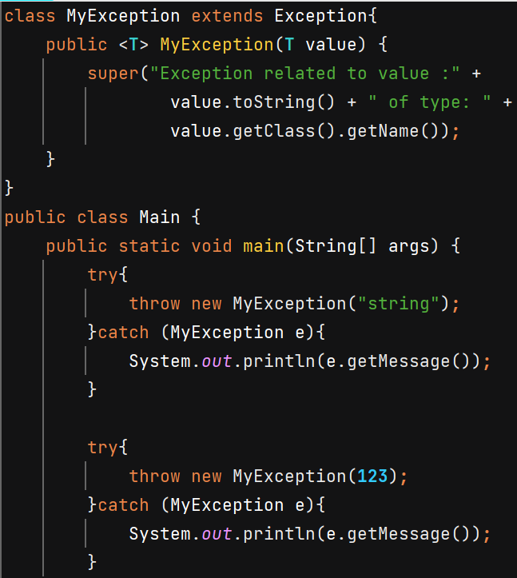

O/P 🡪 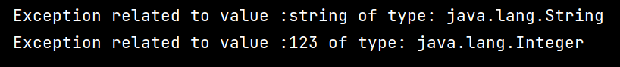

**Passing variable arguments –**

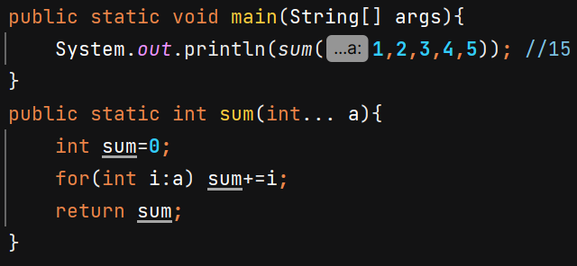 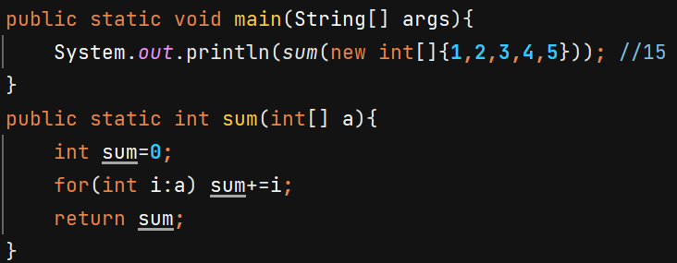

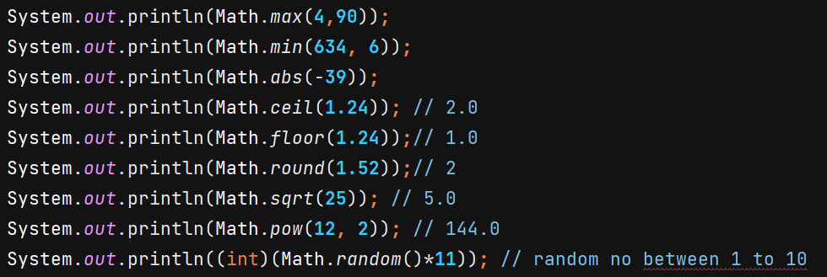

Note :- In a **switch case statement** in Java, if you do not use the break; statement at the end of a case, the program will continue executing the body of all subsequent cases until it encounters a break statement or reaches the end of the switch block.

A **constructor** is a special method in a class that is used to **initialize objects** of that class. It has the following unique properties:

* Its **name is the same as the class name**.
* It **does not have a return type**, not even void.

Types of constructor –

* Default
* Parameterized

We can also overload constructors.

Once you define a **parameterized constructor** in a class, the **default constructor** (provided by Java automatically) becomes no longer available.

**Optional** – needed to avoid null checks everytime

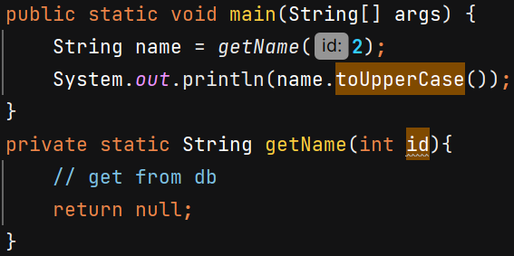 O/P 🡪 NullPointerException

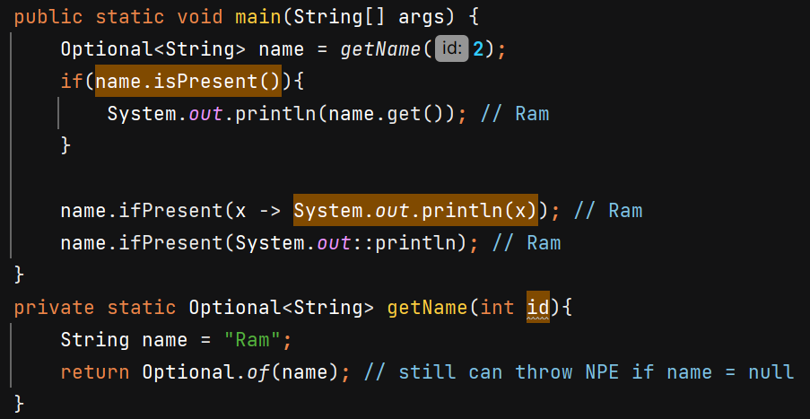

Better to use - 